Microsoft® Product Key Request Form for Specific Scenarios Involving Windows Embedded Products

In order to receive Product Keys for Windows Embedded Products you must:
- Have a current OEM license agreement for Microsoft Embedded products with a Microsoft Licensing entity such as Microsoft Licensing, G.P., Microsoft Ireland Operations Limited or Microsoft (China) Co. Limited.
- Provide the information requested below and submit the completed form by following the process provided at the end of the form.
NOTE: Your use of any keys you receive in connection with this form is subject to your OEM license agreement and applicable product-specific Additional Terms.

This request is for (choose one of the following and complete the corresponding section below):
Please Check One | Purpose for Keys Requested
 | Keys for Enterprise Customer per the rights granted in the BTDE/CLA | Please complete General Information and Section A, below.
 | Keys For Test Units per the rights granted in the BTDE/CLA | Please complete General Information and Section B, below.
 | Keys for Migration Rights per the applicable Schedule in the BTDE/CLA | Please complete General Information and Section C, below.
 | Keys for Downgrade Rights per the applicable Schedule in the BTDE/CLA | Please complete General Information and Section D, below.
 | Keys for Downgrade Rights per Server License Agreement | Please complete General Information and Section E, below.
Please allow 48 hours after submission to OASIGNH to receive an acknowledgement of your request. Our acknowledgement mail will indicate time frame in which keys are expected to be delivered.
If you encounter technical problems, please send inquiry to your Microsoft contact or to OEAHELP@microsoft.com

General information – Please complete for all requests

1 | Date (mm/dd/yyyy)
2 | Microsoft License Agreement or CLA number
3 | Company (OEM) Name
4 | OEM Contact Name
5 | OEM Contact Email Address
6 | Microsoft Contact such as Account Manager or Partner Technical Manager

Section A: Keys for Enterprise Customer per the rights granted in the BTDE/CLA

To qualify for keys under this section, you must have an active Key Usage Agreement in place with the Enterprise Customer per the terms of your BTDE/CLA.
1 | Enterprise Customer Company Name
2 | Enterprise Customer Contact name
3 | Enterprise Customer Physical Address (Street, City, State, Country)
4 | Product for which you are requesting keys, including Microsoft licensable or end item number, and Microsoft product description
5 | Quantity of keys requested

Section B: Keys for Test Units per the rights granted in the BTDE/CLA

1 | Provide the business requirements for the request of Test Keys
2 | Do you already have an OEM Activation Product Key (Client/Server products) OR Brand Activation Key (General Embedded products)?
3 | If you have the activation key (OA Activation OR Brand Activation key), please provide the reason additional keys are being requested
4 | Product for which you are requesting keys, including Microsoft licensable or end item number, and Microsoft product description
5 | Quantity of keys requested

Section C: Keys for Migration Rights per the applicable Schedule in the BTDE/CLA

1 | What are the prior software to be installed and final software to which the system will be migrated? | Prior Software:  Final Software:
2 | Are you currently using OEM Activation technology? If not, are you planning to use OEM Activation?
3 | Are you requesting Migration rights keys to current versions of software available OR for EOL products such as Windows NT/Windows 98?
4 | Product for which you are requesting keys, including Microsoft licensable or end item number, and Microsoft product description
5 | Quantity of keys requested
Section D: Keys for Downgrade Rights per the applicable Schedule in the BTDE/CLA

You are qualified to request keys under this section if the product for which you are requesting downgrade keys is no longer available for distribution under your OEM Agreement.
1 | The product you are licensing for the Embedded System. (i.e. product identified on the COA)
2 | Product for which you are requesting keys, including Microsoft licensable or end item number, and Microsoft product description
3 | Quantity of keys requested

Section E: Keys for Downgrade Rights per Server License Agreement

1 | Please briefly describe the scenario being addressed by your Embedded System design for which the downgrade keys are being requested
2 | What Product is being licensed for the Embedded System?
3 | Will the keys be used for physical installation or virtual installation Or Both?
4 | Product for which you are requesting keys, including Microsoft licensable or end item number, and Microsoft product description
5 | Quantity of keys requested

Please refer to the Table below for guidelines on the eligibility on Server downgrades

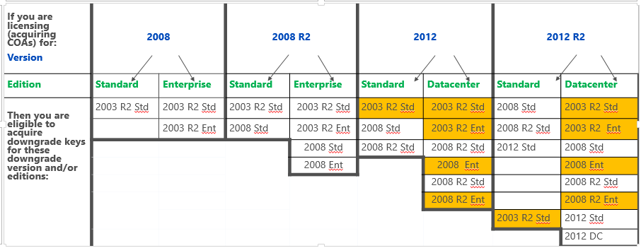

Notes: Requests associated with the color coded products will require additional review and approval by MS

Process for Product Key Request (Review before sending the form to oasignh@microsoft.com)

